About Us:
Our Mission:

To provide a respectful, inclusive and welcoming space for empowering growth, sharing, learning, fun and togetherness for people in our community.
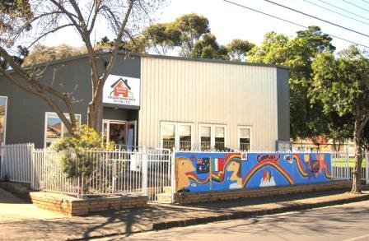Robinson Reserve Neighbourhood House is an incorporated, not-for-profit organisation in South West Coburg, in the City of Moreland. We aim to promote community wellbeing, reduce social isolation, and support and encourage an inclusive, empowered and resilient local neighbourhood. The aims and objectives of our association are detailed here in our Constitution.
Founded in 1988, Robinson Reserve Neighbourhood House is managed by a Committee of Management made up of local residents who have an interest in the community. We receive funding from various sources including Moreland City Council and the Victorian Government to assist us in the running of programs and activities.
We run various educational programs aimed at developing the skill base of the community, such as English classes for migrants, computer classes, Italian classes, art classes and other short courses. We also provide health and wellbeing programs to assist individuals to maintain a healthy outlook and positive life balance. There are also various local community groups who meet regularly for a social catch up and coffee, as well as programs designed around the promotion of community resilience and sustainability.

